**Q1.>** What are the various elements of the Excel interface? Describe how

they're used.

ans.= Various elements of excel interface are:

(a)Quick Access Toolbar- Located in upper left corner of screen, its objective is to show most frequently used excel commands

(b)File Tab- With this we can open or save files, create new sheets, print sheets and perform other file related operations.

(c)Title Bar- Present at top of window and displays active document's name.

(d)Control Buttons- Symbols present in upper right side of window, enabling us to change labels, minimize, maximize, share, close sheet.

(e)Menu Bar- Contains file, insert, page layout, formulas, data, review, view, help and search bar.

(f)Ribbon/Toolbar- Set of commands organized as tabs, groups and commands.

(g)Dialog Box Launcher- Present in lower right corner of command group on ribbon.

(h)Name box- Shows location of active cell,row,or column.

(i)Formula Bar- Permits us to observe,insert or edit info./formula entered in active cell.

(j)Scrollbar- Enables us to move documents vertical and horizontal views.

(k)Spreadsheet Area- Place where we enter our data.

(l)Cells- It divides spreadsheet into many pieces,separating rows and columns.

**Q2.>** Write down the various applications of Excel in the industry.

ans.= (a) MS excel is a spreadsheet application used to manipulate stored data.

(b) Finance and accounting professionals choose excel for its complex analytical and computing features.

(c) It enables users to identify trends and organize and sort data into meaningful categories.

(d) Also performs Human Resources functions.

(e) Also helps in presenting performance reports.

**Q3.>** On the ribbon, make a new tab. Add some different groups, insert

commands in the groups and name them according to their commands

added. Copy and paste the screenshot of the steps you followed.

ans.= 1st step- Click on home and then select customize the ribbon option.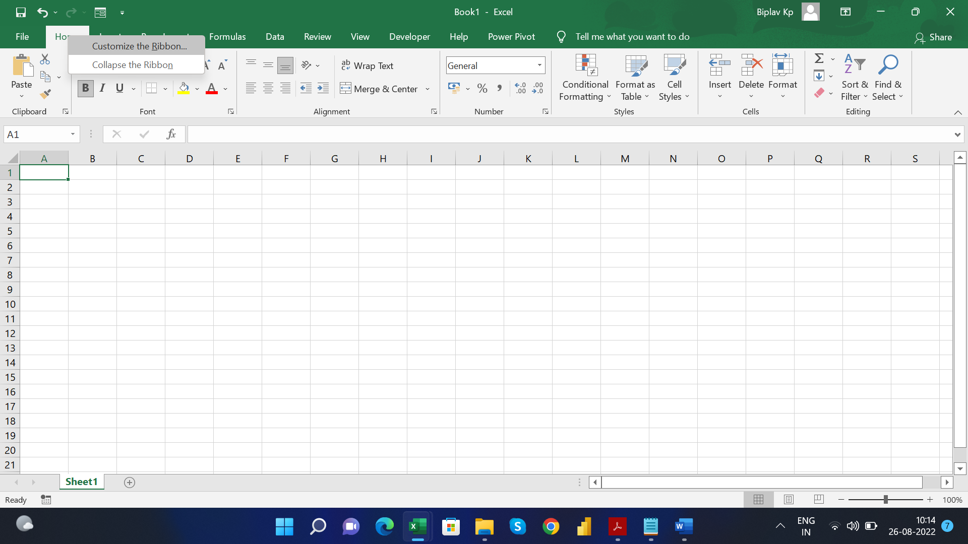

2nd step is to click on new tab and then click on new group and create new group accordingly.

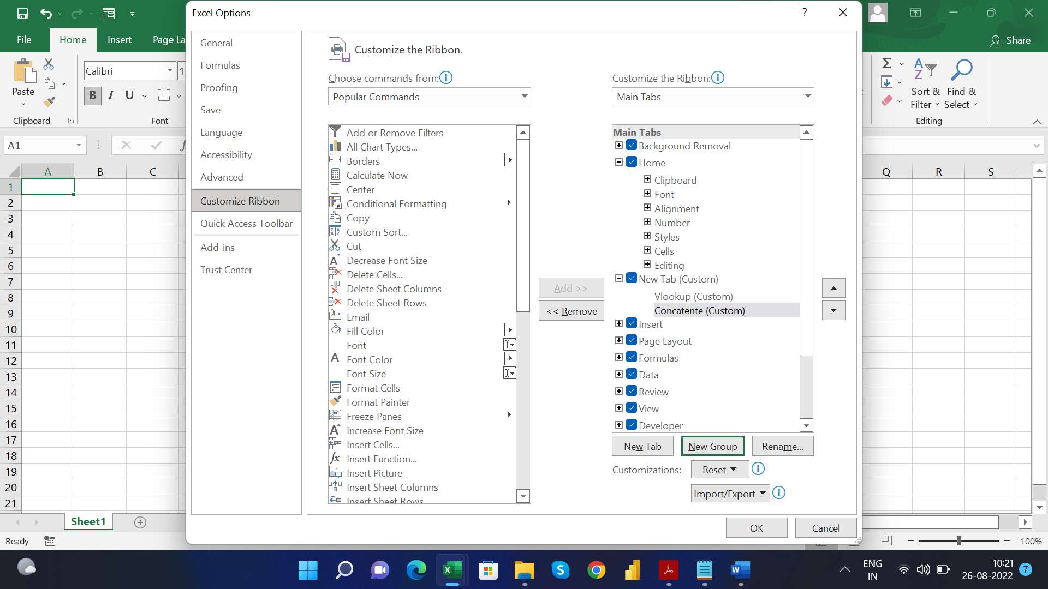

**Q4.>** Make a list of different shortcut keys that are only connected to

formatting with their functions.

ans.= Various shortcut keys to format data in excel are:

(a) CTRL+2 or CTRL+B- used to make text bold.

(b) CTRL+3 or CTRL+I- used to make text italic.

(c) CTRL+4 or CTRL+U- used to underline text.

(d) ALT+H,FA- used to open alignment dialog box.

(e) ALT+H,FN- used to open front dialog box.

(f) ALT+H,FK- used to make font size of text smaller.

(g) ALT+H,FG- used to make font size of text larger.

(h) ALT+H,B- used to add border.

(i) CTRL+1- used to open format cell dialog box.

(j) CTRL+Shift+Percent(%)- used to apply percentage format with no decimal places.

(k) Shift+F8- used to add a non adjacent cell or range to selection of cells.

**Q5.>** What distinguishes Excel from other analytical tools?

ans.= Excel is a wonderful tool to represent data on x and y axis.It organizes large set of data from different resources,analysizes it and present it in meaningful manner.Its cost effective too and has got great online access.It's a great way of presenting useful info in colouful way.

**Q6.>** Create a table and add a custom header and footer to your table.

ans.= Added header and footer to the table